Name: Stanislaw Gregor Kowalski
Event Type: Naturalization
Event Date: 1932
Event Place: Cleveland, Cuyahoga, Ohio, United States
Age: 20
Birth Year:
Birth Year (Estimated): 1912
Birthplace: Poland
GS Film number: 2251611
Digital Folder Number: 005486574
Image Number: 01390

Citing this Record:
"Ohio, County Naturalization Records, 1800-1977," database with images, FamilySearch (https://familysearch.org/ark:/61903/1:1:K8H9-CZG : accessed 11 October 2015), Stanislaw Gregor Kowalski, 1932; citing Naturalization, Ohio, Cuyahoga, county courthouses, Ohio; FHL microfilm 2,251,611.

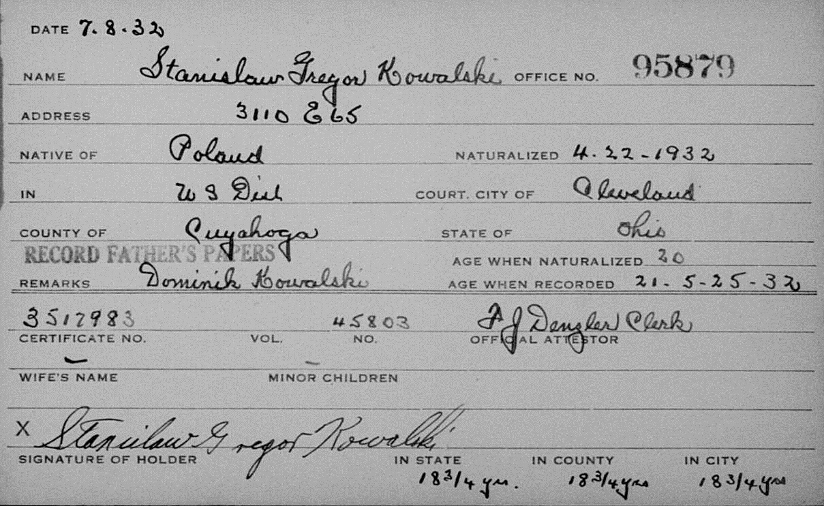

Brother of Casimer Kowalski

