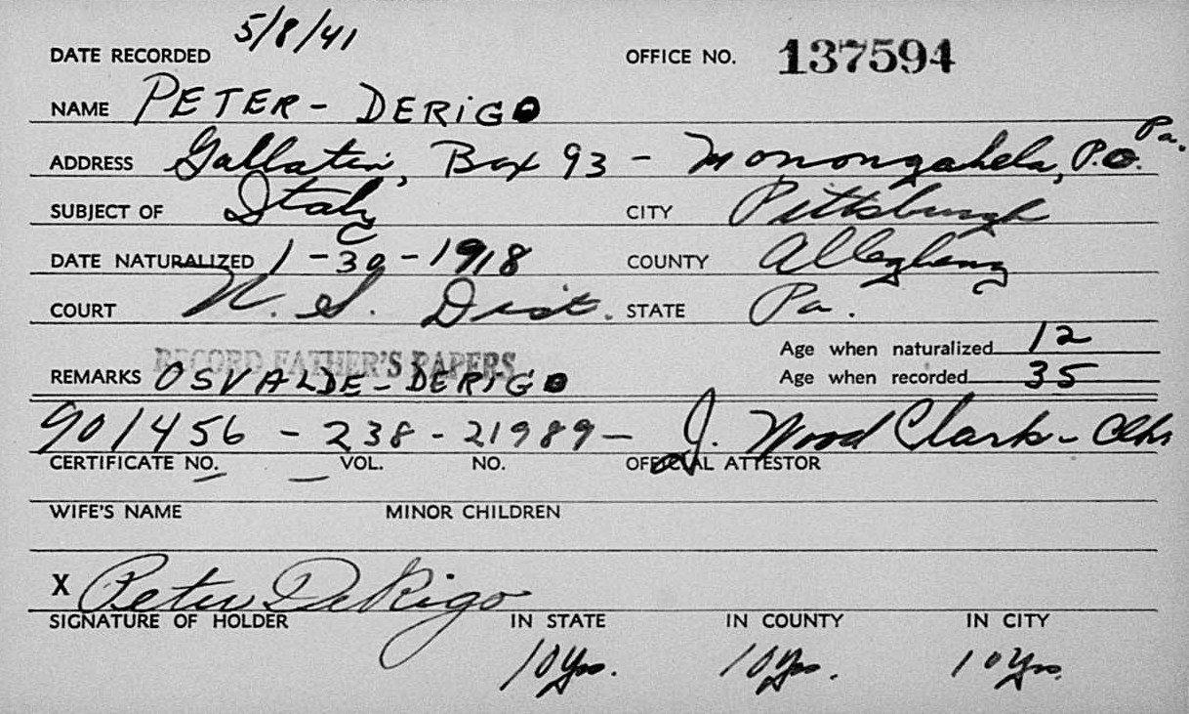
name: | Peter Derigo
event: | Naturalization
event year: | 1918
event place: | Pittsburgh, Cuyahoga, Ohio, United States
age: | 12
birth year:
estimated birth year: | 1906
birthplace: | Italy
film number: | 2247220
digital folder number: | 005486567
image number: | 03521

Citing this Record
"Ohio, County Naturalization Records, 1800-1977," index and images, FamilySearch (https://familysearch.org/pal:/MM9.1.1/K841-16X : accessed 29 Jan 2013), Peter Derigo, 1918.

