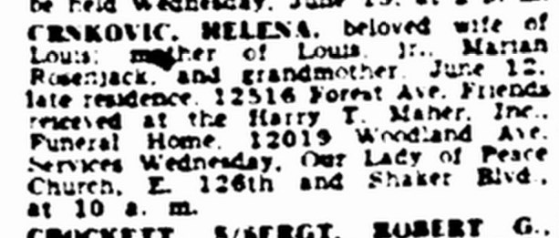
Obituary of Helen Benicki Crnkovic
The Cleveland Plain Dealer
14 Jun 1949
Page 23, Column 1

