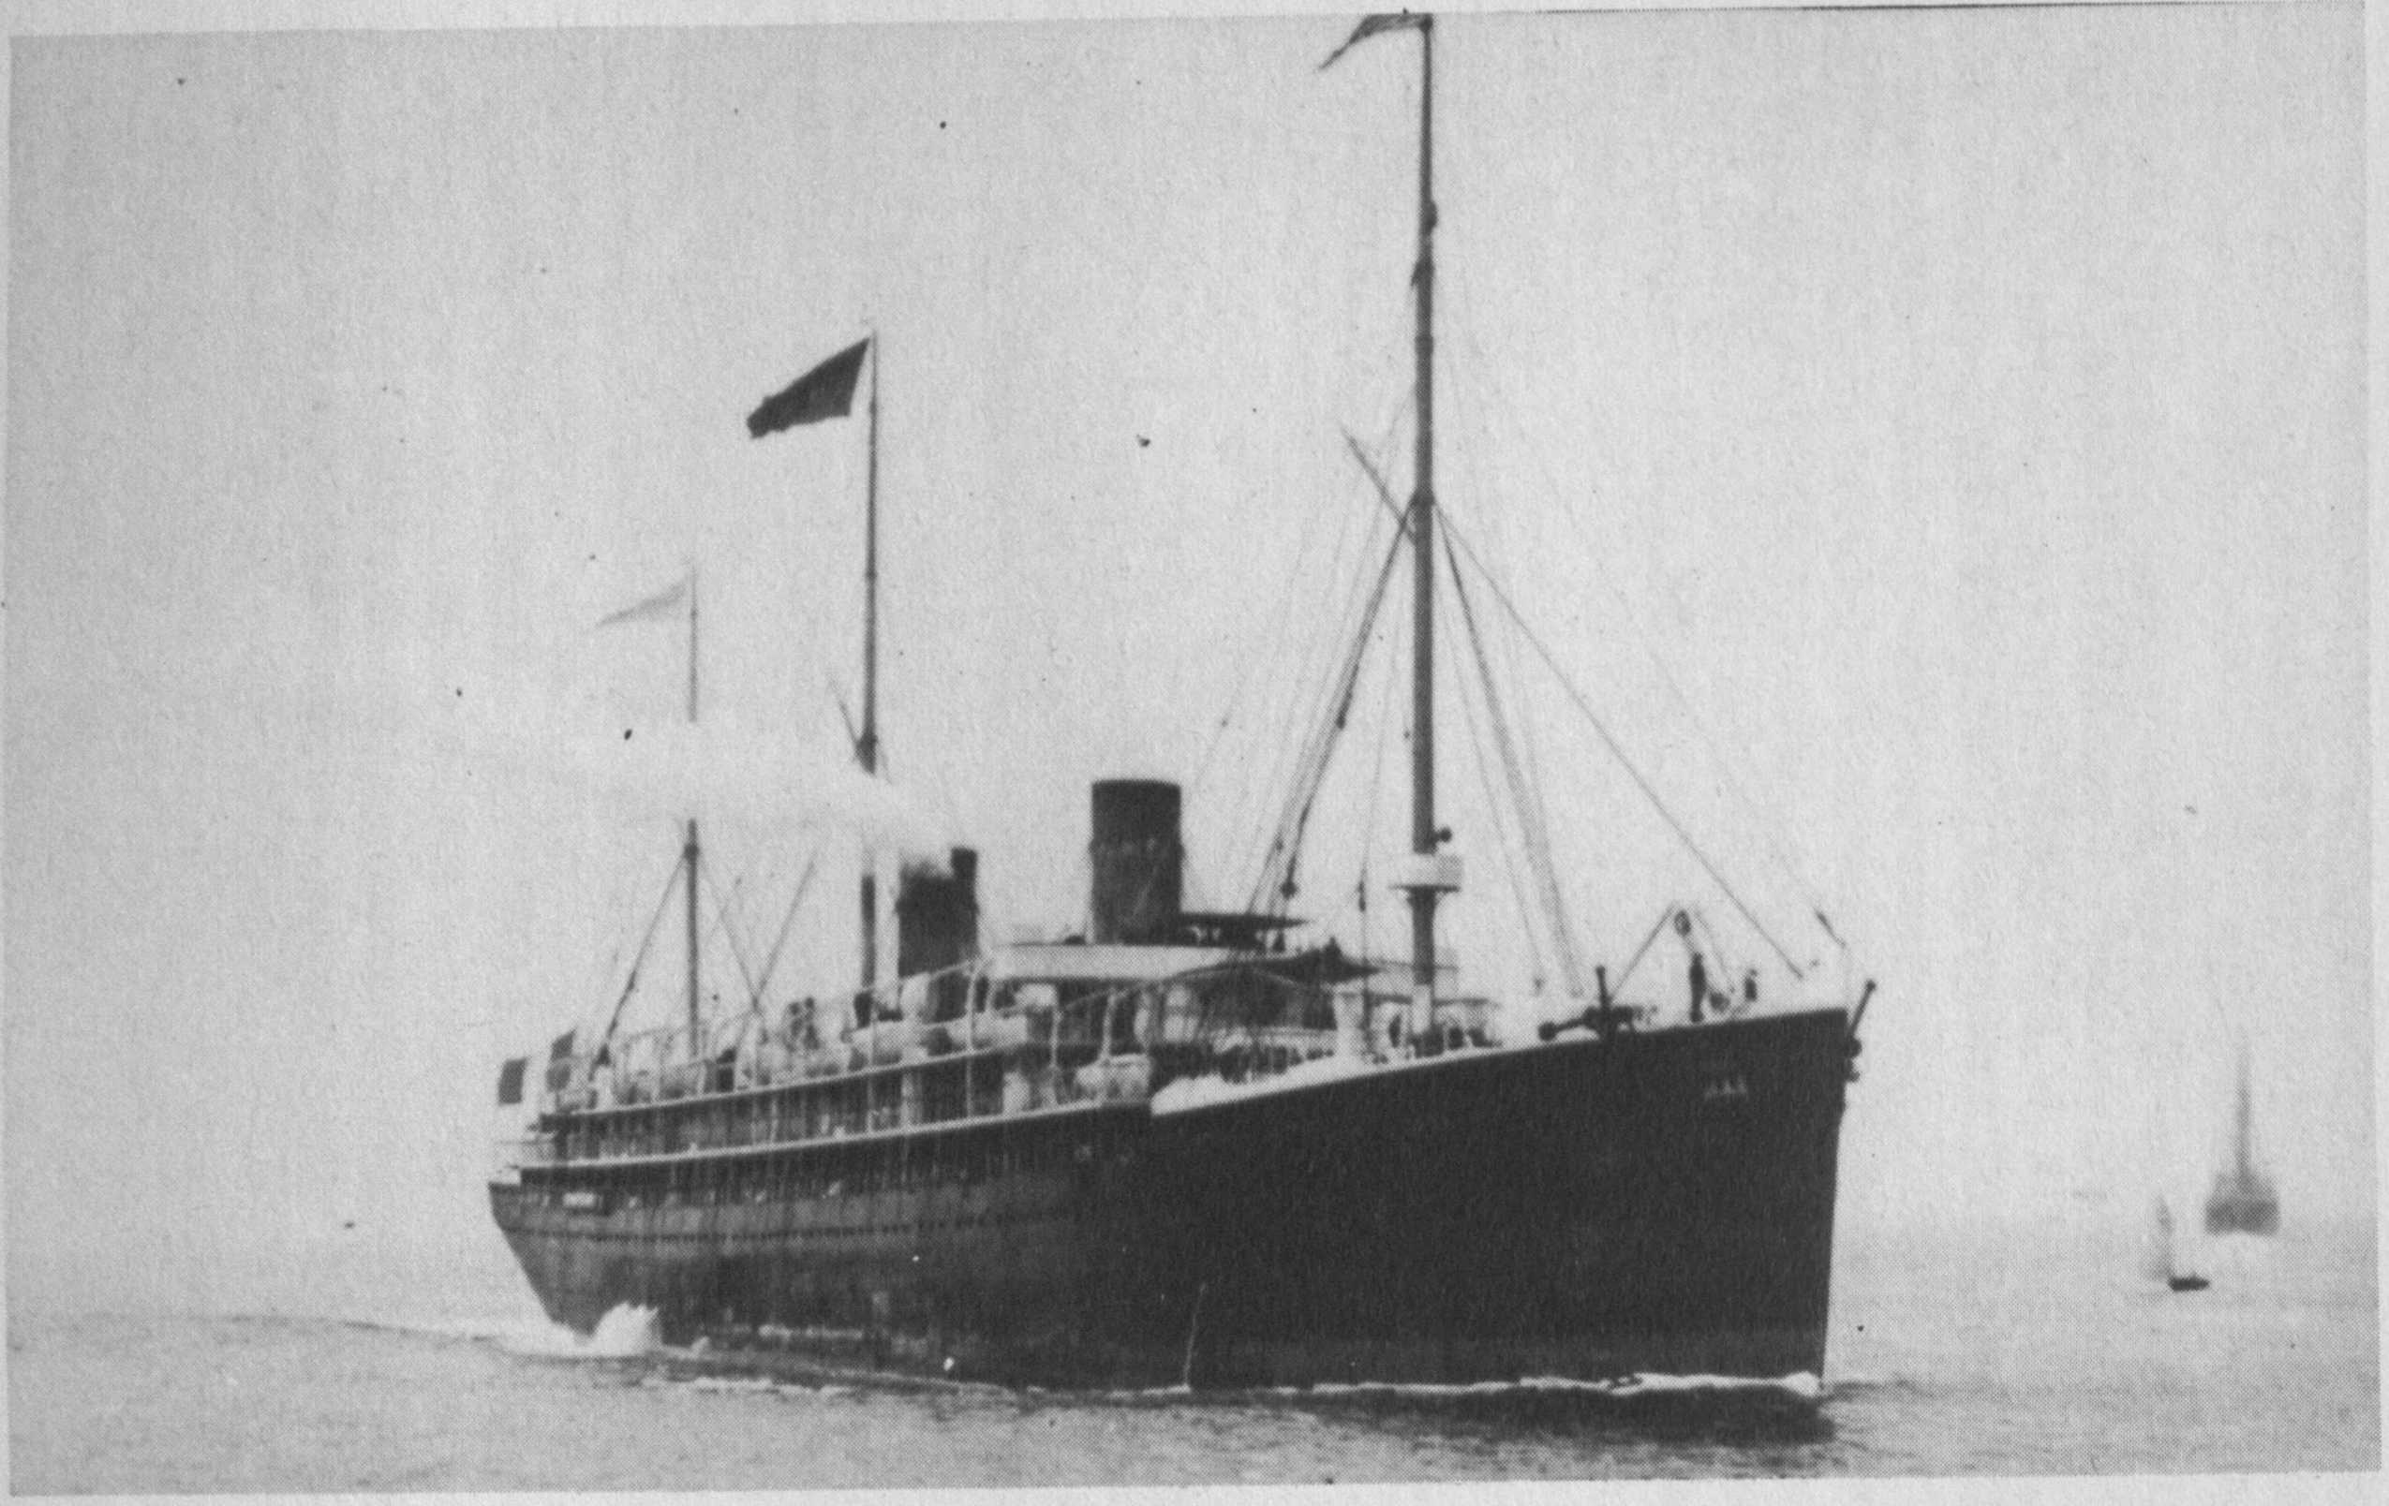

Ship Information

|  |  |  |  |  |  |  |  |  |  |  |  |  |  |  |
| --- | --- | --- | --- | --- | --- | --- | --- | --- | --- | --- | --- | --- | --- | --- |
| |  |  | | --- | --- | | Ship Name: | La Touraine | | Years in service: | 1891-1924 | | Funnels: | 2 | | Masts: | 3 | | Shipping Line: | Compagnie Generale Transatlantique | | Ship Description: | Built by Chantiers de Penhoet, St. Nazaire, France. Tonnage: 9,047. Dimensions: 520' x 56' (536' o.l.). Twin-screw, 19 knots. Triple expansion engines. Three masts and two funnels. | | History: | Launched, March 21, 1890. Maiden voyage: Havre-New York, June 20, 1891. At later date one mast was removed. Made a fast crossing from Havre to New York in 6 days, 18 hours. Made her final voyage to New York in 1922. Scrapped in France, 1924. | |